# **[Personal Notes API](https://github.com/devrajKhadka-smiley/Personal-Note-API.git)**

## Overview

The Personal Notes API is a RESTful service designed for managing personal notes. It enables users to create, read, update, and delete notes. These notes persisted by being stored in local JSON files, with various middleware functions utilized for logging requests, validating inputs, and handling errors.

## Technologies used

## Node.js: JavaScript runtime environment used to build server-side logic.

## Express: A web framework employed to develop the RESTful API.

## CORS: Middleware to enable Cross-Origin Resource Sharing, allowing the API to be accessed from different domains.

## Core Node.js Modules:

## fs: Handles file system operations to store notes in a JSON file.

## path: Manages and resolves file paths.

## API Endpoints

### Get all notes

* + Endpoint: `/api/notes`
  + Method: ` GET `
  + Description: Retrieve all notes stored in the JSON File

### Get a note by ID

* + Endpoint: `/api/notes/:id`
  + Method: `GET`
  + Description: Fetches a specific note based on the provided ID.
  + Parameter: `id` (The ID of the note to retrieve)

### Add a new note

* + Endpoint: ` /api/notes`
  + Method: `POST`
  + Description: Adds a new note with the provided title and content.
  + Request body: Requires title and content fields (both mandatory).

### Update a note by ID

* + Endpoint: `/api/notes/:id`
  + Method: `PUT`
  + Description: Updates an existing note using its ID.
  + Request body: Requires the note’s title and content for the update.

### Delete a note by ID

* + Endpoint: `/api/notes/:id`
  + Method: `DELETE`
  + Description: Removes a note based on the provided ID.
  + Parameter: `id` (The ID of the note to delete)

## Middleware

### Logging Middleware

* + **Description**: Logs details of every incoming request, including the HTTP method, URL, and the timestamp of the request.

### Validation Middleware

* + **Description**: Ensures that required fields (title and content) are present in requests. It also validates the ID provided in the request parameters.

### Error Handling Middleware

* + **Description**: Provides consistent error messages in response to any errors encountered by the API.

## Data Storage

The notes are stored in a file named db.json, located within the data directory of the project.

## How to Run the Project

* + Navigate to the main project directory and open a terminal.
  + Run `npm install` to install all dependencies.
  + Install necessary packages by running `npm install express cors nodemon`.
  + Start the project by executing `npm –watch node.js` in the terminal. The application will run on http://localhost:3000.

## POSTMAN Configuration

A Folder structure is created for easy access and understanding of API endpoints.

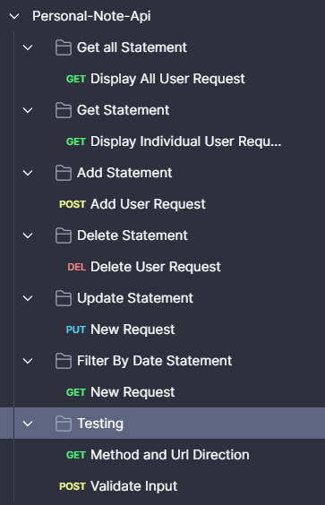

1. Get All Note.

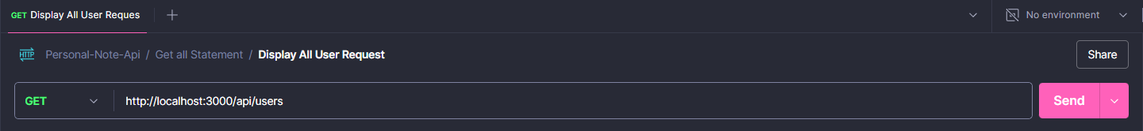

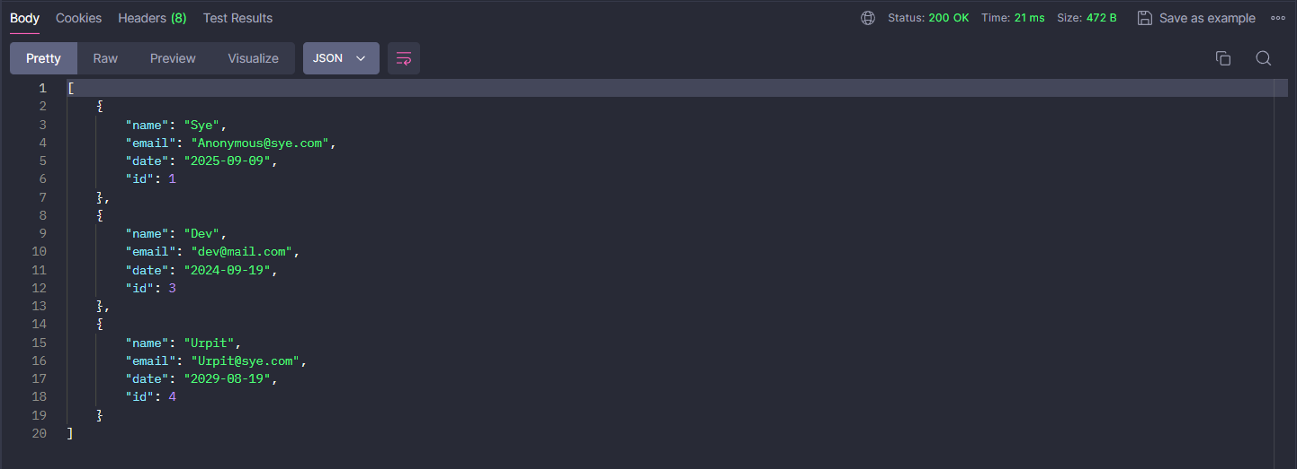

1. Get Specific Note

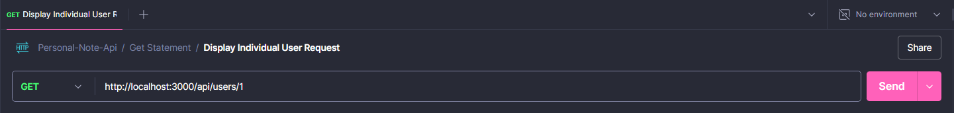

1. Add a Note.



1. Delete a Note.

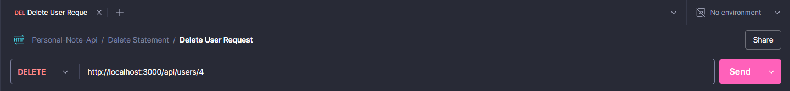

1. Update a Note.

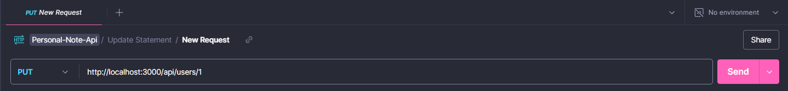

1. Filter by Date Statement:

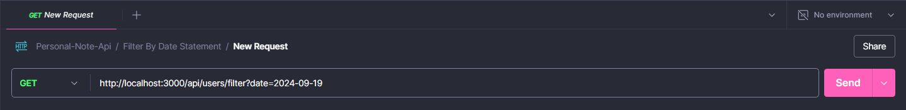

1. Testing
   1. Method and URL Direction

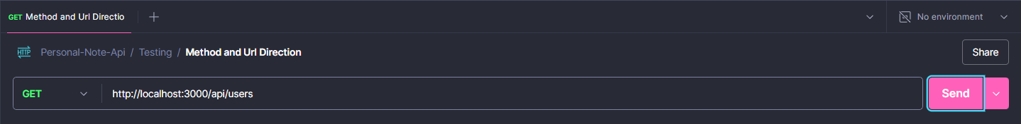

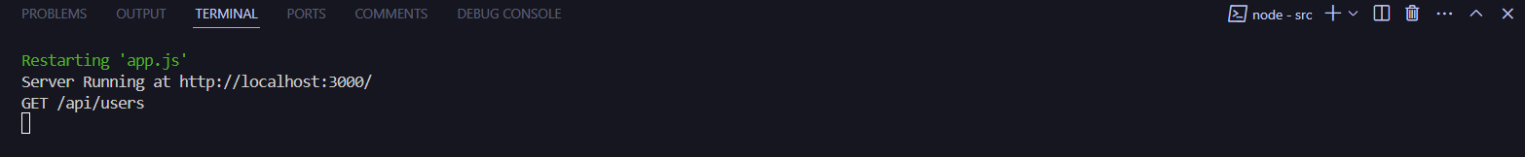

* 1. Input Validation

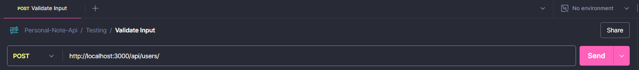

## GitHub Profile

https://github.com/devrajKhadka-smiley/Personal-Note-API.git